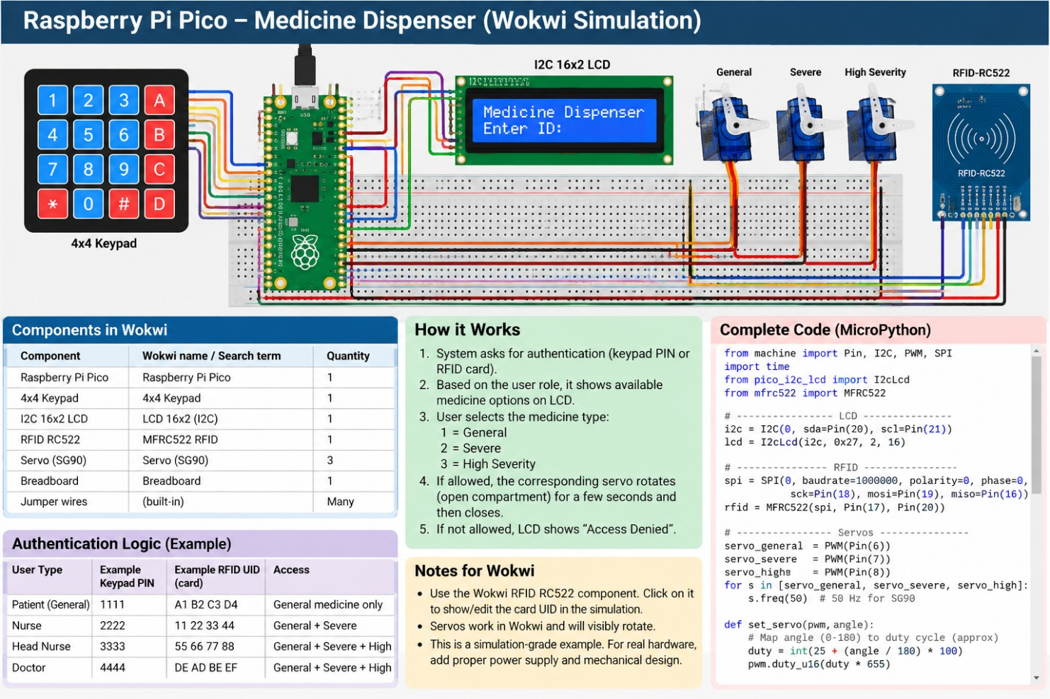

Medicine Dispenser Simulation Using Raspberry Pi Pico in Wokwi
You can simulate your medicine dispenser using a Raspberry Pi Pico, a 4×4 keypad, three servo motors, and status indicators in Wokwi. This lets you demonstrate user authentication, medicine access restrictions, and automatic compartment opening without buying hardware. Because even virtual medicine cabinets need access control.
The simplest starting point is keypad-based authentication. Once that works, you can add an RFID reader for card-based authentication.
1. Circuit diagram
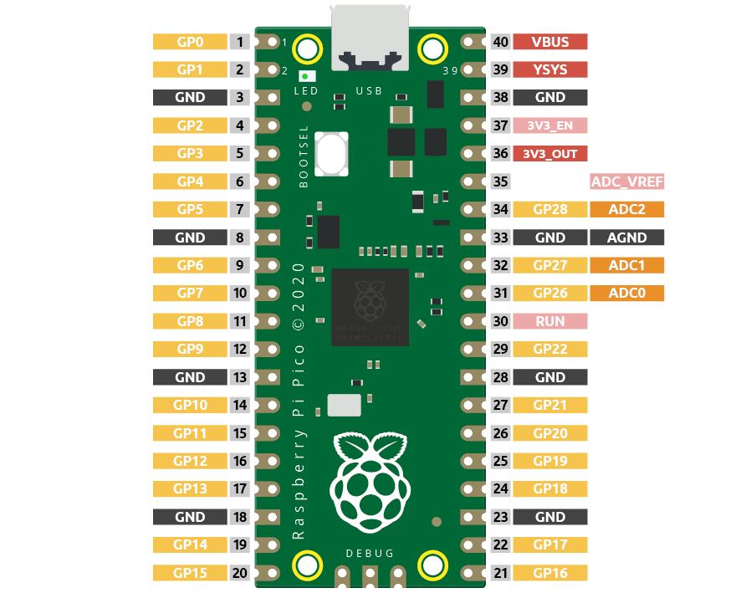
Main components
- Raspberry Pi Pico
- 4×4 matrix keypad
- 3 × SG90 servo motors
- 3 LEDs with current-limiting resistors
- Breadboard and jumper wires
- Optional buzzer and LCD
The generated project infographic below is a conceptual overview. Use the exact GPIO connections in the wiring table and code that follow.
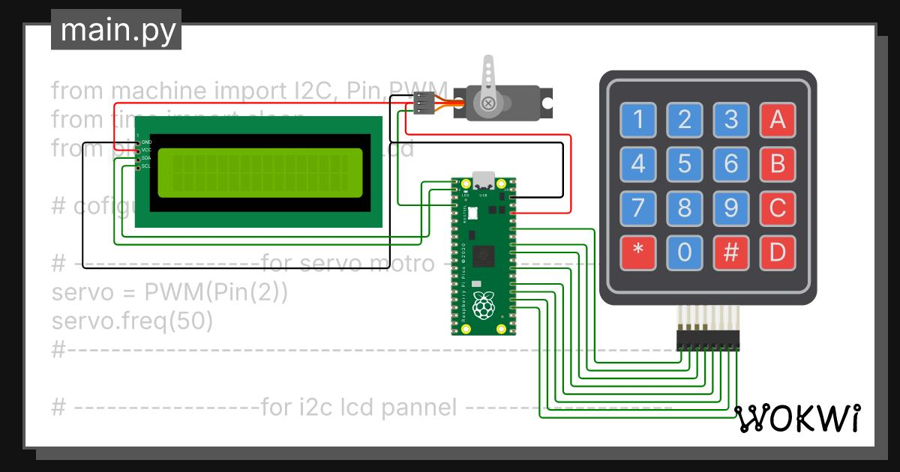
2. Add these components in Wokwi
Open Wokwi at wokwi.com and create a new Raspberry Pi Pico project.
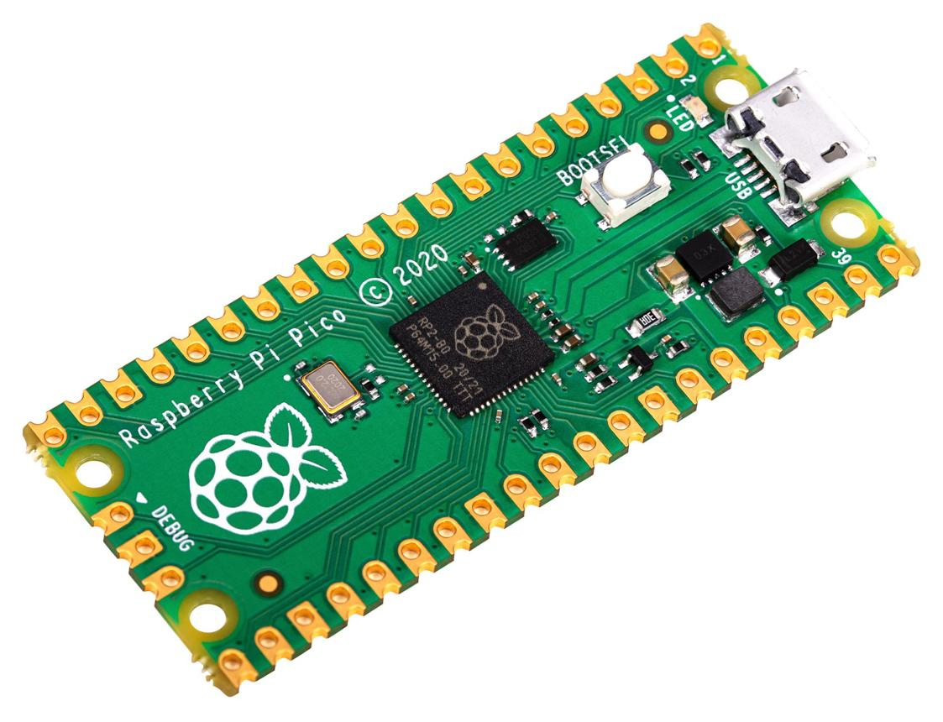
1. Raspberry Pi Pico
Quantity: 1 · Main controller
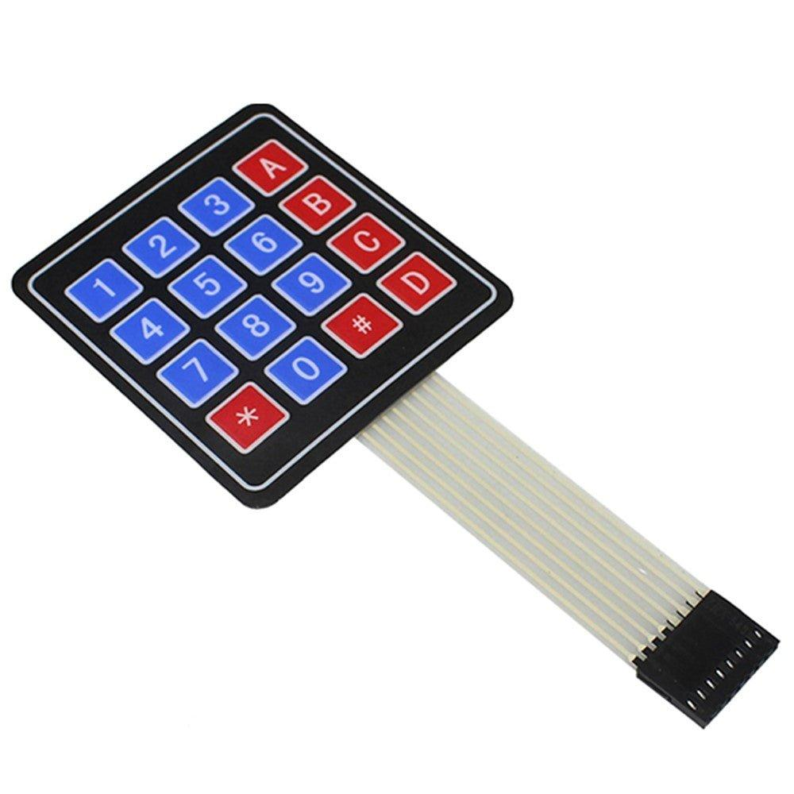
2. 4×4 keypad
Quantity: 1 · User PIN and medicine selection

3. SG90 servo
Quantity: 3 · One for each medicine compartment
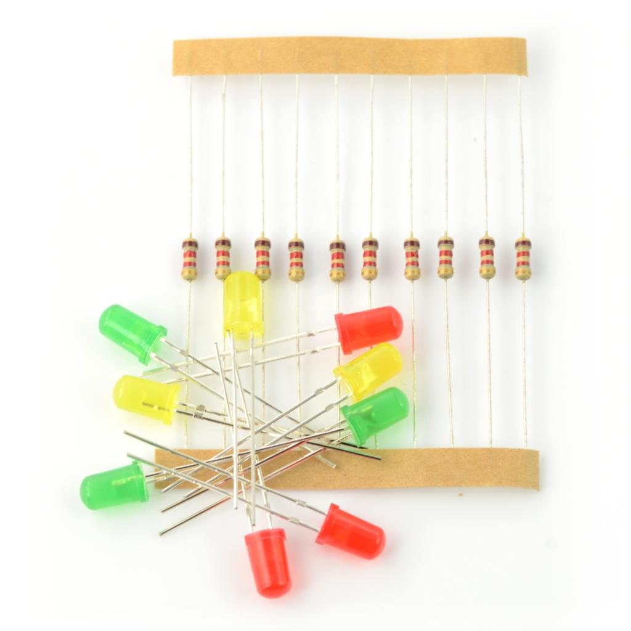
4. LEDs and resistors
Quantity: 3 LEDs, 3 × 220–330 Ω resistors

5. Optional buzzer
Quantity: 1 · Denied access or error indication
3. Circuit connections
Connect the components to these Raspberry Pi Pico GPIO pins. In Wokwi, select each component and connect its pins using the diagram editor.
Component pin | Pico connection
Keypad R1, R2, R3, R4 | GP0, GP1, GP2, GP3
Keypad C1, C2, C3, C4 | GP4, GP5, GP6, GP7
General medicine servo signal | GP16
Severe medicine servo signal | GP17
High-severity servo signal | GP18
General medicine LED | GP19
Severe medicine LED | GP20
High-severity medicine LED | GP21
Buzzer signal, optional | GP22
Servo VCC | 5V external supply or suitable simulated supply
Servo GND | GND, shared with Pico
LED cathodes | GND through the circuit's return path
For each LED, wire the Pico GPIO to a resistor, then to the LED anode, and connect the LED cathode to GND. Use the common ground for the servos and Pico. On physical hardware, do not power three servos from the Pico's 3.3 V output.
Important: The table defines the authoritative wiring for the code below. The earlier RFID/LCD infographic shows a possible expanded design, not an exact pin-by-pin schematic for this keypad-only version.
4. Authentication and medicine access rules
The simulation uses example PINs. These are test credentials only, not a secure real-world authentication system.
User role | Example PIN | General | Severe | High severity
Patient / attender | 1111 | Yes | No | No
Nurse | 2222 | Yes | Yes | No
Head nurse | 3333 | Yes | Yes | Yes
Doctor | 4444 | Yes | Yes | Yes
The system will:
- Ask the user to enter a PIN.
- Check which role the PIN belongs to.
- Accept medicine selection 1, 2, or 3.
- Check the role's permission for that compartment.
- Turn on the matching LED and rotate the servo if access is permitted.
- Return the servo to its closed position after a short delay.
- Deny unauthorized requests.
5. Complete MicroPython code
Create a file named main.py in the Wokwi project and paste this code. It uses the Pico's built-in machine module, so no extra Python libraries are required.

from machine import Pin, PWM
from time import sleep

# ---------- KEYPAD ----------
rows = [
Pin(0, Pin.OUT),
Pin(1, Pin.OUT),
Pin(2, Pin.OUT),
Pin(3, Pin.OUT)
]

cols = [
Pin(4, Pin.IN, Pin.PULL_UP),
Pin(5, Pin.IN, Pin.PULL_UP),
Pin(6, Pin.IN, Pin.PULL_UP),
Pin(7, Pin.IN, Pin.PULL_UP)
]

keys = [
['1', '2', '3', 'A'],
['4', '5', '6', 'B'],
['7', '8', '9', 'C'],
['*', '0', '#', 'D']
]

# ---------- SERVOS ----------
servo_pins = [16, 17, 18]
servos = []

for pin_num in servo_pins:
servo = PWM(Pin(pin_num))
servo.freq(50)
servos.append(servo)

# ---------- STATUS LEDs ----------
6. Run the simulation
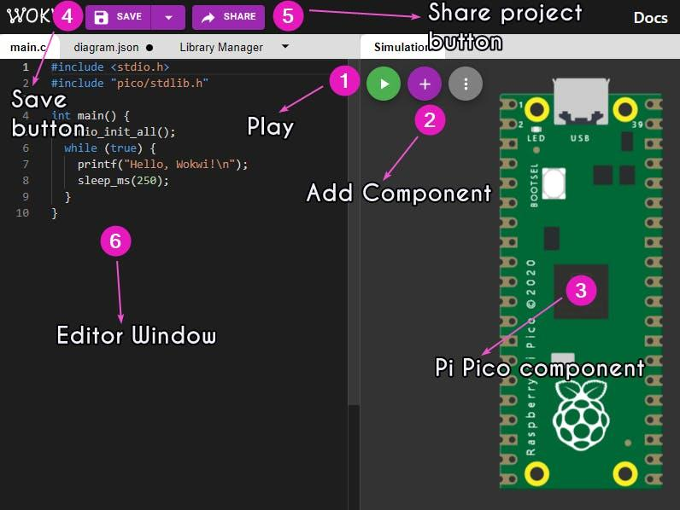
Step 1: Start
Click Start Simulation in Wokwi. Open the serial console to view authentication messages and access decisions.
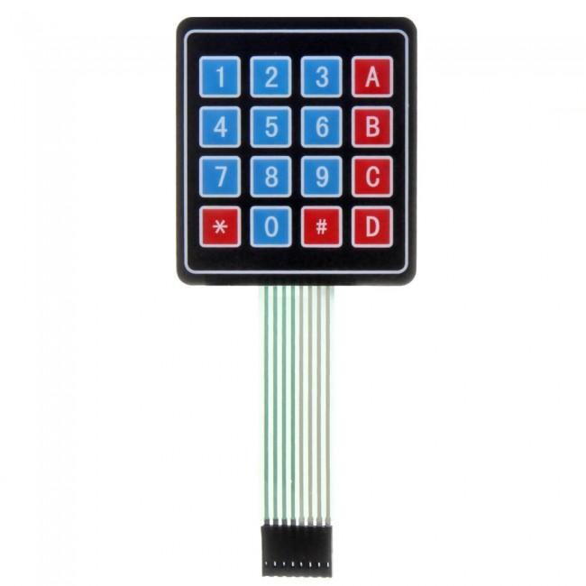
Step 2: Authenticate
Click the keypad buttons and enter 1111, followed by #. The serial console confirms the patient role.
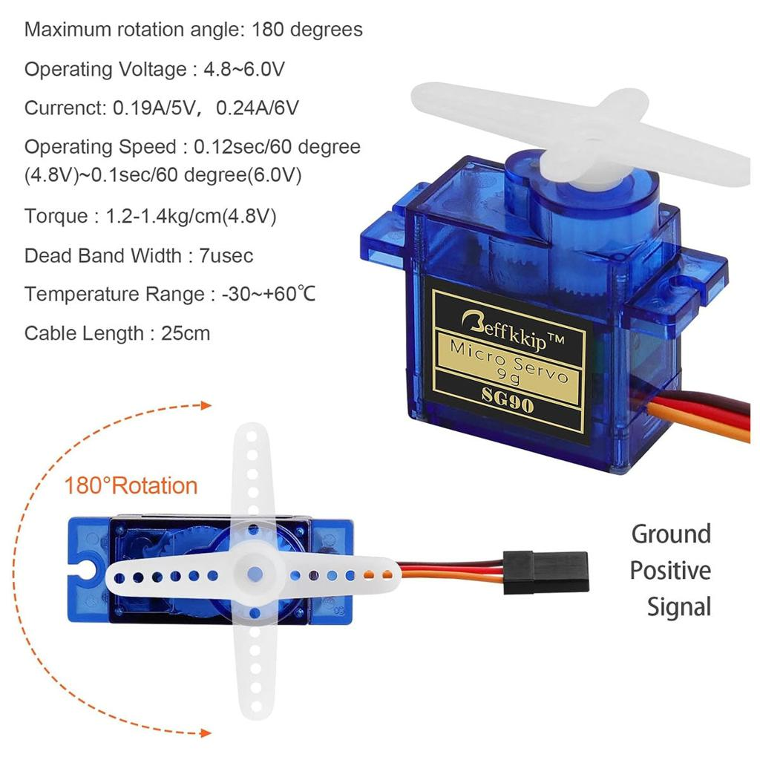
Step 3: Test permissions
Press 1 to open the general compartment. Log in again as the nurse using 2222#, then press 2 to test severe medicine access.
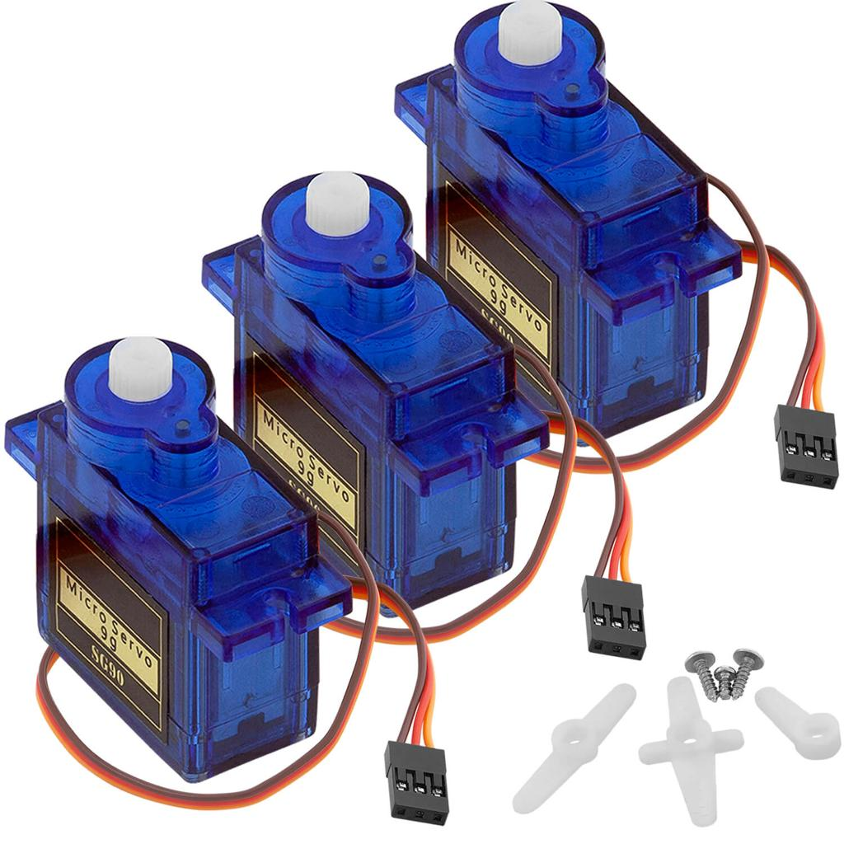
Step 4: Test denied access
Log in as a patient and press 3. The high-severity compartment must remain closed and the serial console should show ACCESS DENIED.
7. Test cases for your project demonstration
Test | Input | Expected result
Patient gets general medicine | 1111#, then 1 | Servo 1 opens and closes
Patient requests severe medicine | 1111#, then 2 | Access denied
Nurse gets severe medicine | 2222#, then 2 | Servo 2 opens and closes
Nurse requests high-severity medicine | 2222#, then 3 | Access denied
Doctor requests high-severity medicine | 4444#, then 3 | Servo 3 opens and closes
Invalid PIN | 9999# | Authentication rejected
8. How to extend it with RFID
Once the keypad version works, add an MFRC522 RFID reader to the Pico and configure it to recognize registered card UIDs. The RFID card should identify a user, and the same role-permission checks should apply regardless of whether the user authenticated by PIN or card.
Wokwi project resources: Raspberry Pi Pico documentation · Keypad documentation · Servo documentation.
One important limitation: this is a prototype of access control, not a clinically validated dispenser. For a real hospital device, PIN storage, audit logs, prescription validation, dispensing confirmation, and fail-safe mechanical controls would all need proper design and testing.

